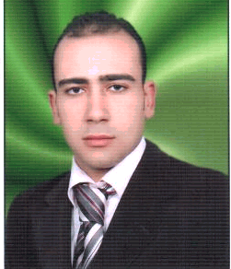
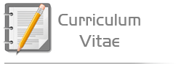

Name : Ahmed Mohamed Ibrahim Yousef  Age : 27  Date of birth : 26/9/1987  Address : 3rd district -5th complex New Cairo - Cairo  Mobile : 01098871922  Telephone :055-3480318  Marital status : Single  Military status : Exempted  Email : AY_medo200@hotmail.com | About me ?
- The effective contribution to the society and utilizing my experience and knowledge.  - Solving the technical problems of implementing of information systems in business.  - Designing programs in accordance with the modern standards.  - Joing a world class team having special skills.  - Understanding the influence of business administration solutions on societies.  - Need to progressive education.  - Analyzing, designing and applying information systems to solve various problems.  - Applying the models of decision making on the administrative problems.  - Development and self development through the development of scientific and practical skills and try new experiences. | Objectives
- Graduated from obour Academy.  - Bachelor in information systems.  - Year of graduation is May 2008.  - Grade: good.  - Designing a project of ticket reservation Egypt Air.  - Grade of graduation project was excellent. | Education

- Certificate Microsoft Certified Systems Administrator On Microsoft Windows 2003 server (MCSA).  - Microsoft Technology Specialist (MCTS).  - Certificate Microsoft Certified Systems Engineer On Microsoft windows 2003 Server (MCSE).  - Certificate Microsoft certified it professional on Microsoft Windows 2008 Server (MCITP).  - Microsoft Certified Solutions Associate on Microsoft Windows 2008 Server (MCSA).  - Microsoft Internet Security and Acceleration )ISA( Server 2006,Configuration  - Microsoft Certification ID : 8196764 | International Certificates
- ICDL certificate from Sesco institute in 2008.  - Good command of both written and spoken English . | Training Course
- Exllant Computer skills.  - Very good communication skills.  - Work Under pressure.  - Work inside a team. | The skills
- 1: I worked in Arab Gulf Center.  Job description : computer engineer, search in internet, publishing articles and books in amazon, Elsevier and other sites.  From : 10/06/2008 To: 14/10/2008  - 2 :I worked in Tarzy for Exchange.  Job description : help desk.  From : 15/07/2008 To : 30/10/2009  - 3:I Worked in Call Center Link.net.  Job description : Technical support Mail And Domain).  From : 16/02/2010 To : 12/01/2012  4: I worked in vodafone  Job description : Customer Care .  From : 10/06/2012 To : 13/09/2012  5: I Work in Call Center (Xceed Account TEData up Q)  Job description : Technical Support ADSL.  From: 22/09/2012 to 27/9/2014  6: Iwork in raya (Etisalat Emraits HS)  Job description : technical support ADSL, Iwan, Gpon, mail&domain, hosting, land line and lasdline | Expertises
- Arabic : Very Good.  - English : Good. | Languages

